HR Insights Platform
High-Level Design (HLD)
Version 3.0 | 11 September 2026
Document attribute | Value
Application | HR Insights Platform
Submission intent | Vodafone Architecture Review, Security Review, SPDA / C3 and Production Readiness
Status | Draft for review
Confidentiality | C3 (final classification to be confirmed by the Information Owner)
AI scope | Out of Phase 1 scope; planned as a Phase 2 future enhancement (see Future Roadmap)
Document owner | TBC
SPDA demand | TBC
Design Authority demand | TBC
Project phase | Development phase design and approval
Master location | SharePoint location (TBC)

Table of Contents

1. Document Control and Governance 4
1.1 Revision History 4
1.2 Reviewers, Approvers and Distribution 4
2. Executive Summary 4
3. Business Context and Scope 5
3.1 Business Need 5
3.2 In Scope 5
3.3 Out of Scope 5
3.4 Assumptions, Dependencies and Constraints 6
4. Requirements and Architecture Principles 6
4.1 Functional Requirements 6
4.2 Non-Functional Requirements 6
4.3 Architecture Principles 7
5. Solution Overview and Target Architecture 7
5.1 Architecture Diagram and Tools 7
5.2 Architecture Flow 8
5.3 Environment Model 9
6. Detailed Application and Integration Design 9
6.1 Frontend 9
6.2 Integration / Messaging Contract 9
6.3 Frontend Dependencies 10
6.4 Backend API Contract 10
6.5 Backend Dependencies 11
6.6 Read Sequence 11
6.7 Write Sequence 12
6.8 Future / Phase 2 AI Sequence 12
7. Data Architecture and BigQuery Design 12
7.1 Data Ownership and Minimization 12
7.2 Datasets and Views 12
7.3 Partitioning, Clustering and Lifecycle 12
8. Identity, Authentication and Authorization 12
8.1 Authentication 12
8.2 Authorization Chain 13
8.3 Role Matrix 13
8.4 Identity and Service Account Separation 13
8.5 Access Lifecycle 14
9. Security and Compliance 14
9.1 Data Classification and Privacy 14
9.2 PII Handling and Pseudo-anonymization 14
9.3 Immutable Audit and Logging 15
9.4 SPDA Compliance Mapping 15
10. Logging, Monitoring and Operational Support 16
10.1 Logging Model 16
10.2 Metrics, SLOs and Alerts 16
10.3 Support Model and RACI 16
10.4 Runbooks Required 17
11. CI/CD and DevSecOps 17
11.1 Target Pipeline 17
11.2 Required Gates 17
11.3 Patch and Dependency Management 18
12. Future Roadmap 18
13. Appendices 18
Appendix A – Glossary 18
Appendix B – Source Register 19

Page numbers populate automatically when this document is opened in Word. If prompted, choose “Update entire table”; otherwise select the table and press F9.

1. Document Control and Governance

1.1 Revision History
Version | Date | Status | Change | Owner
1.0 | 12 Aug 2026 | Initial | Core HLD baseline covering dashboard, analytics consumption and controlled data access. | TBC
1.1 | 08 Sep 2026 | Draft | Restructured into the Vodafone approval-readiness HLD format. | TBC
3.0 | 11 Sep 2026 | Draft for review | Revised as HR Insights Platform: reclassified to C3; adopted the latest solution architecture; removed AI from Phase 1 (retained as a Phase 2 roadmap item); tabulated the environment model; incorporated BigQuery Row-Level and Column-Level Security into the authorization chain; added the Admin role; replaced application-data encryption with pseudo-anonymization; and rationalised sections. | TBC

1.2 Reviewers, Approvers and Distribution
Role | Name / team | Decision / responsibility | Status
Document owner | TBC | Accuracy and design ownership | Drafted
Business Owner / Sponsor | TBC | End-to-end solution | Pending
Architecture reviewer | TBC | Architecture pattern and delta | Pending
Application / solution architecture | Design Authority | End-to-end architecture approval | Pending
SPDA / Secure by Design | TBC | Security demand approval | Pending
Privacy / Information Owner | TBC | Classification, purpose, retention and PII | Pending
PCS / GCP platform | TBC | C3 hosting, logging and project guardrails | Pending
DataHub / Analytics owner | TBC | Datasets, semantic views and access | Pending

2. Executive Summary
The HR Insights Platform is a ReactJS and GCP based analytics and insight delivery platform designed to help HR and business users understand the drivers behind top talent nomination across Vodafone markets. It provides a single interface for viewing analytics model outputs, including global predictor insights and market-level driver and barrier analysis.
The platform is a presentation and query layer only. Analytical modelling is performed upstream by the analytics team, with published outputs consumed from BigQuery. Data access is controlled through authentication and group-based authorization, enforced through the backend and through BigQuery Row-Level and Column-Level Security applied at query time.

3. Business Context and Scope

3.1 Business Need
The HR Insights Platform gives HR and business users a single, governed place to understand why individuals are nominated as top talent across Vodafone markets. It surfaces published analytics outputs – global predictor insights and market-level driver and barrier analysis – through an interactive dashboard, reducing fragmented and uncontrolled distribution of sensitive HR analytics and supporting consistent, scope-based consumption of insight.

3.2 In Scope
- ReactJS single-page dashboard on Cloud Run for HR Insights Platform, including the global predictor view and market-level driver and barrier views.
- FastAPI backend on Cloud Run consuming published BigQuery analytics outputs and semantic views.
- Application access control through Google Group membership, resolved by Identity-Aware Proxy.
- Cloud Load Balancer, Cloud Armor and Identity-Aware Proxy at the edge, with corporate SSO.
- BigQuery Row-Level Security (by market) and Column-Level Security (Policy Tags) enforced at query time.
- Central logging, monitoring and audit of application activity.
- Separate development (non-live) and production (live) environments on GCP.

3.3 Out of Scope
- Analytical and model development, which is performed by upstream analytics teams; the platform is a presentation and query layer only.
- Changes to upstream HR data pipelines.
- Changes to source HR systems.
- Development or ownership of upstream ETL and data-engineering processes.
- Redesign of the enterprise data or semantic layer.
- Changes to published analytical outputs.
- Uncontrolled, anonymous or external (non-Vodafone) user access.
- Any functionality outside the defined HR Insights Platform scope.

3.4 Assumptions, Dependencies and Constraints
ID | Type | Statement
A01 | Assumption | Analytics model outputs and semantic views are produced and refreshed upstream of the platform in BigQuery.
A02 | Assumption | Corporate identity integration (SSO and Identity-Aware Proxy) is available for the target projects.
D01 | Dependency | Published BigQuery analytics outputs and semantic views are provisioned and accessible to the backend identity, with Row-Level and Column-Level Security configured.
D02 | Dependency | Cloud Armor, IAP and DNS / certificate are provisioned for the target projects.
D03 | Dependency | Google Groups map users to their permitted market scope.
C01 | Constraint | HR analytics data must remain within approved Vodafone projects and regions.
C02 | Constraint | The platform consumes published outputs only and does not change the underlying HR data pipelines.

4. Requirements and Architecture Principles

4.1 Functional Requirements
ID | Requirement | Priority
FR01 | View global predictor insights across Vodafone markets. | Must
FR02 | View market-level driver and barrier analysis within the permitted scope. | Must
FR03 | Return only data within the user’s resolved scope, enforced server-side and by BigQuery Row-Level and Column-Level Security. | Must
FR04 | Authenticate users through corporate SSO and resolve access scope before any data is retrieved. | Must
FR05 | Provide a simulation view to adjust factors and evaluate relative odds against a baseline (Phase 2). | Should
FR06 | Provide a consolidated overview page of key metrics and insights (Phase 2). | Should

4.2 Non-Functional Requirements
ID | Domain | Target / requirement
NFR01 | Security | Authentication and authorization aligned with Vodafone security standards, with backend entitlement enforcement on every request.
NFR02 | Security | Encryption of data in transit (HTTPS / TLS).
NFR03 | Security | Compliance with C3 security and SPDA review requirements.
NFR04 | Scalability | Scalable, cloud-native architecture hosted on GCP services (Cloud Run).
NFR05 | Performance | High availability and reliable API performance for dashboard interactions.
NFR06 | Security | Secure CI/CD deployment using Vodafone-approved pipelines.
NFR07 | Maintainability | Read-only consumption of published views; the platform holds no local copy of HR data.

4.3 Architecture Principles
- Zero trust between browser, frontend and backend: authenticate and authorize every request.
- Presentation and query layer only; analytical modelling remains upstream.
- The backend is the single point of entitlement enforcement; no data-access logic sits in the frontend.
- Use approved GCP managed services and existing Vodafone deployment and operations patterns.
- Consume published, governed BigQuery outputs; do not duplicate HR data.

5. Solution Overview and Target Architecture
The HR Insights Platform is deployed on GCP using Cloud Run for the ReactJS frontend and the FastAPI backend. BigQuery serves as the interface between the upstream analytics work and the platform, which reads published views and does not hold its own copy of HR data. Authorization is enforced by the backend and by BigQuery Row-Level and Column-Level Security applied at query time.

5.1 Architecture Diagram and Tools
Zone | Component | Responsibility
User | HR User (corporate browser) | Access the platform and authenticate through corporate SSO.
GCP edge | Cloud Load Balancer | Distribute traffic to the platform over HTTPS.
GCP edge | Cloud Armor | WAF and attack-shield protection with rate limiting.
GCP edge | Identity-Aware Proxy (IAP) with Google Groups | Authenticate the user and resolve Google Group membership (application access control), establishing an authenticated user session.
Compute | Cloud Run – Frontend (React app) | Serve the ReactJS dashboard single-page application.
Compute | Cloud Run – Backend (FastAPI) | Validate REST / JWT requests, apply the authenticated user context, query BigQuery and return responses.
Data | BigQuery | Published analytics outputs and semantic views, with Row-Level Security (by market) and Column-Level Security (Policy Tags) enforced at query time; returns authorized, filtered data.
Operations | Cloud Logging | Collect audit and operational logs.
Delivery | GitHub, CI/CD, Artifact Registry | Build, package and deploy immutable container images.

Figure 1. HR Insights Platform – Solution Architecture
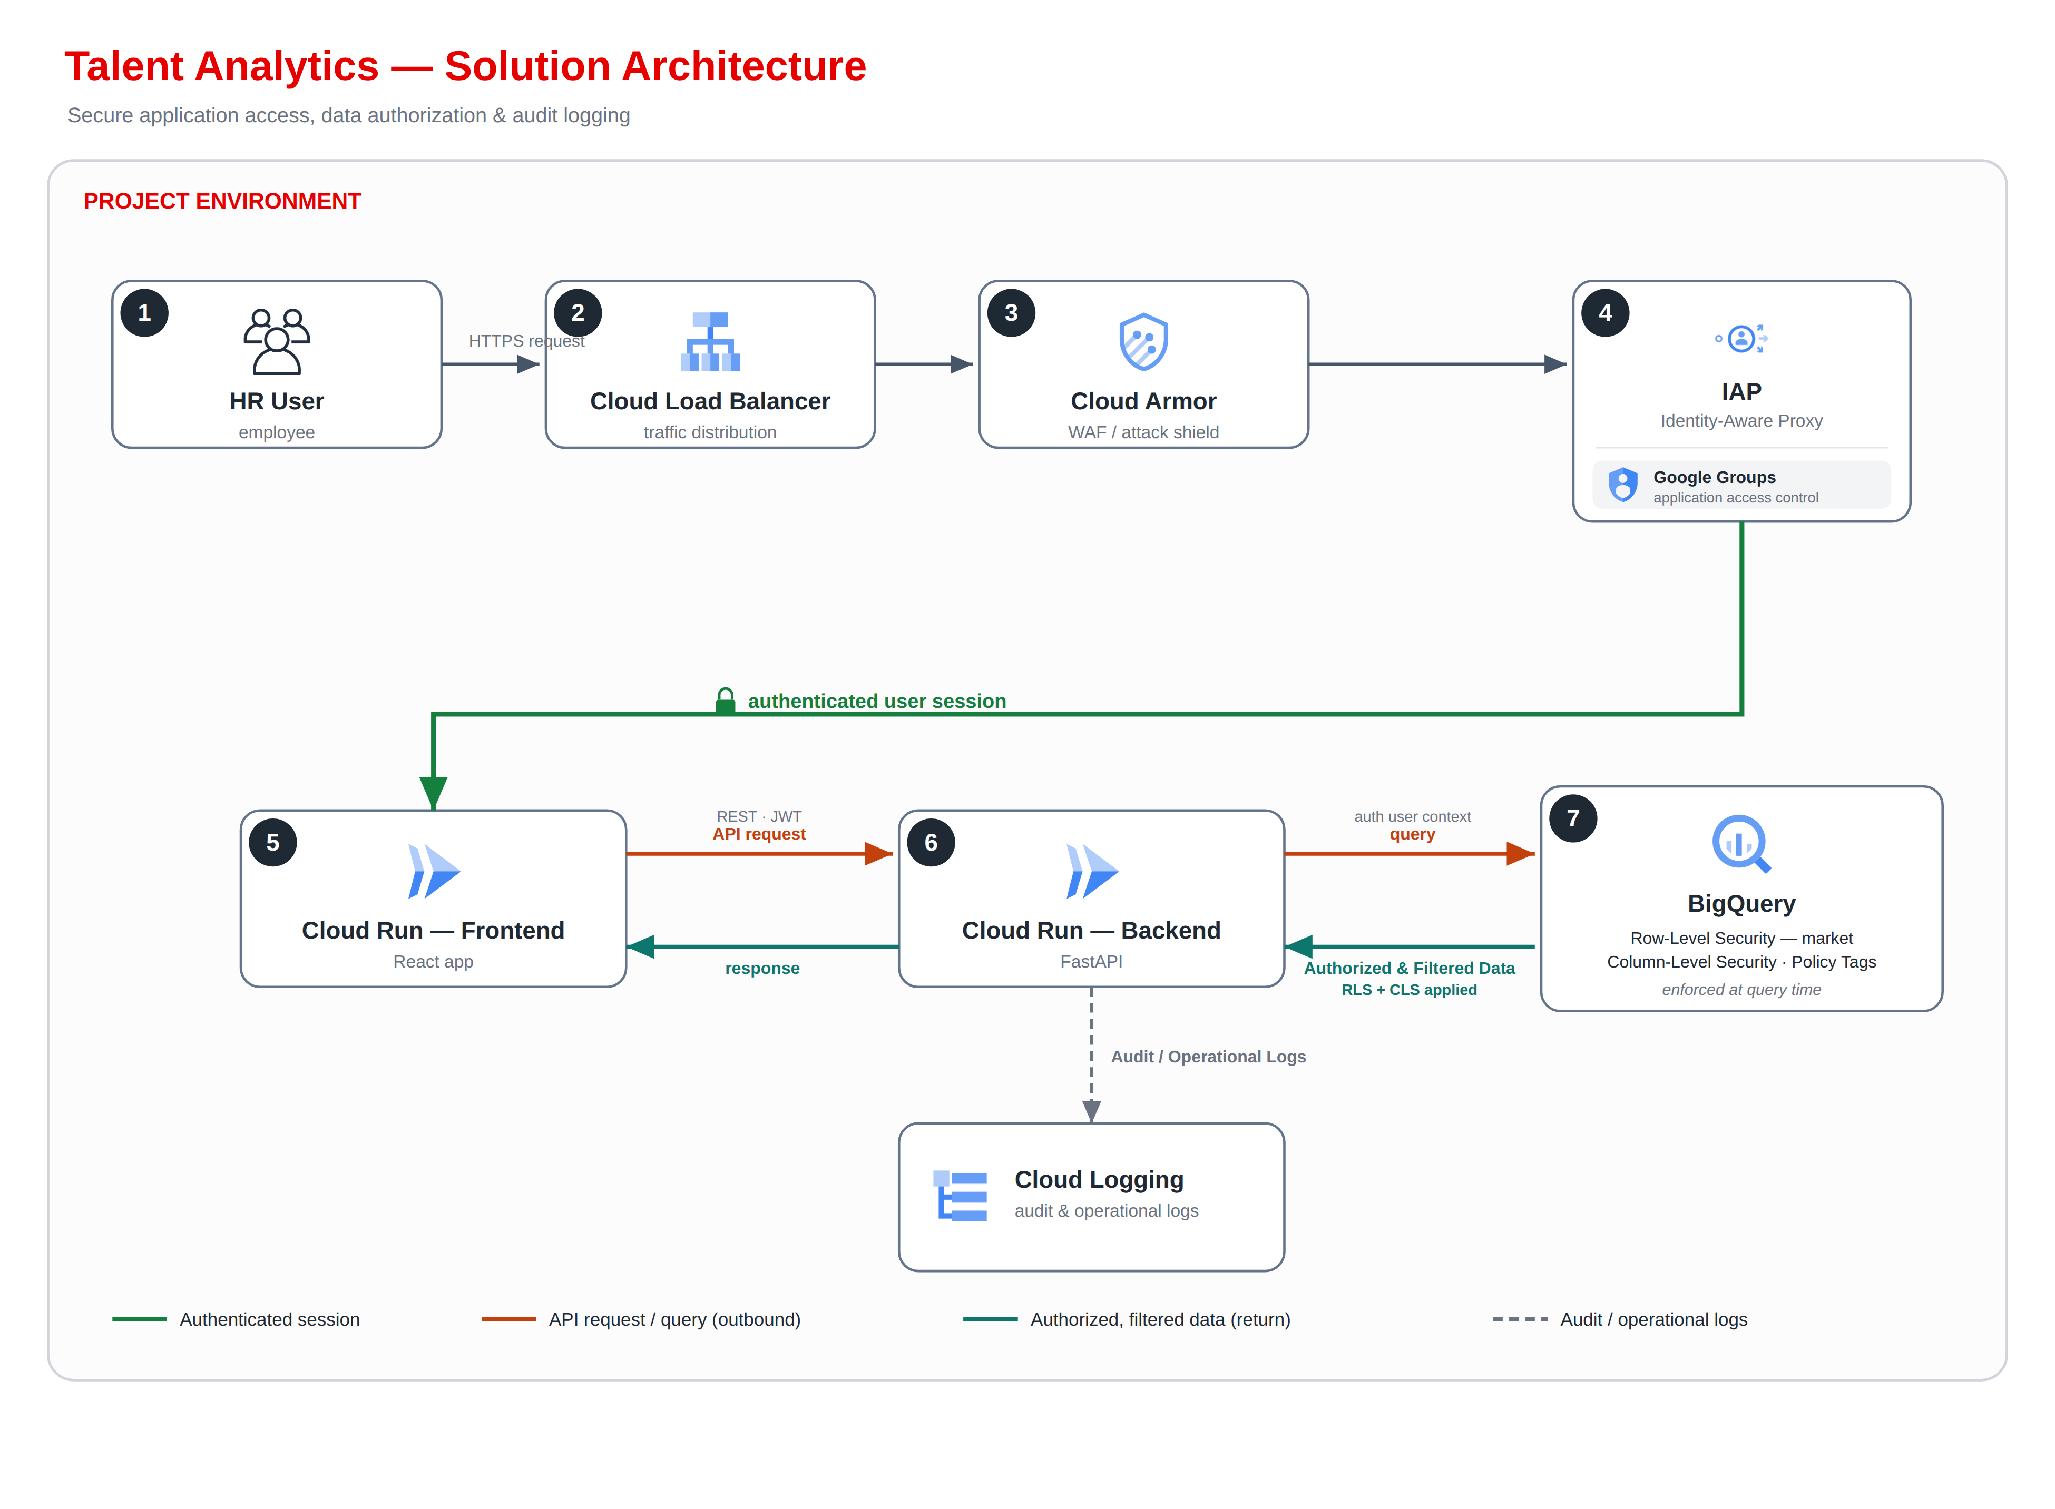

5.2 Architecture Flow
- The HR user sends an HTTPS request to the platform; Cloud Load Balancer distributes the traffic.
- Cloud Armor applies WAF and attack-shield policies with rate limiting.
- Identity-Aware Proxy authenticates the user and resolves Google Group membership (application access control), establishing an authenticated user session.
- The ReactJS frontend (Cloud Run) receives the authenticated session and issues a REST API request, carrying JWT context, to the FastAPI backend (Cloud Run).
- The backend validates the request and queries BigQuery using the authenticated user context.
- BigQuery enforces Row-Level Security (by market) and Column-Level Security (via Policy Tags) at query time and returns authorized, filtered data.
- The backend returns the response to the frontend, which renders the insight visualizations.
- The backend writes audit and operational logs to Cloud Logging.

5.3 Environment Model
The HR Insights Platform follows Vodafone’s GCP governance model, with separate non-live and live environments. Application services (the ReactJS frontend and the FastAPI backend) are deployed on Cloud Run. Monitoring, logging and audit are centrally managed using Google Cloud services.
Environment | Project / Platform | Purpose | Key Characteristics
Non-Live / Development | vf-cip-ca-nonlive | Development and testing | Used for application development, integration testing and validation.
Live / Production | vf-cip-datahub | Production | Production environment for approved HR Insights Platform users.

6. Detailed Application and Integration Design

6.1 Frontend
- ReactJS single-page application hosted on Cloud Run, providing interactive dashboard views for HR Insights Platform.
- Serves display and user-interaction logic only; does not hold authorization policy or direct BigQuery credentials.
- Renders the insight visualizations using scoped results returned by the backend API.
- Uses same-origin /api calls where possible to simplify CORS and IAP behavior.
- Renders returned data as text; any HTML is rejected or sanitized using an approved library, and output is encoded.
- Applies a restrictive Content-Security-Policy (including object-src none and base-uri none, with an explicit connect-src) and disallows embedding of the application.
- Does not access BigQuery directly and does not persist identity tokens, roles or scoped results in browser storage.

6.2 Integration / Messaging Contract
The frontend integrates with the backend exclusively over authenticated HTTPS REST APIs, with JSON request and response payloads. There is no direct frontend-to-BigQuery integration and no client-side data-access path. The contract is governed by the following rules:
Field | Rule
Origin / CORS | Exact environment-specific origin allowlist for the frontend; never use “*” for allowed origins.
Transport | HTTPS / TLS only; each request carries the authenticated user context established by Identity-Aware Proxy, propagated as JWT between the Cloud Run frontend and backend.
Request validation | Type, length, character and key allowlists; reject unknown keys, excessive nesting and over-size payloads.
Trust | Any identity, role or scope values supplied by the client are ignored for security decisions; the backend re-derives identity and scope from the verified IAP / JWT context.
Correlation | Each request carries a correlation identifier for tracing and consistent handling.
Errors | Generic error responses; internal details are not exposed to the client.
Logging | Record the rejection reason and correlation ID without values that expose C3 content.

6.3 Frontend Dependencies
Package | Version | Type
react | 19.2.6 | Dependency
react-dom | 19.2.6 | Dependency
@eslint/js | 10.0.1 | Dev Dependency
@types/node | 24.12.3 | Dev Dependency
@types/react | 19.2.14 | Dev Dependency
@types/react-dom | 19.2.3 | Dev Dependency
@vitejs/plugin-react | 6.0.1 | Dev Dependency
eslint | 10.3.0 | Dev Dependency
eslint-plugin-react-hooks | 7.1.1 | Dev Dependency
eslint-plugin-react-refresh | 0.5.2 | Dev Dependency
globals | 17.6.0 | Dev Dependency
typescript | 6.0.2 | Dev Dependency
typescript-eslint | 8.59.2 | Dev Dependency
vite | 8.0.12 | Dev Dependency

6.4 Backend API Contract
The backend API layer runs on Cloud Run and is built with FastAPI. It validates incoming requests, applies the authenticated user context, queries BigQuery, and returns scoped results to the frontend. It is the controlled processing boundary between the frontend and the BigQuery datasets, and it is the authoritative point of entitlement enforcement.
Method / endpoint | Purpose | Role | Security behavior
GET /healthz | Runtime health | Platform | No sensitive dependency details.
GET /api/v1/insights/global | Global predictor insights | Authenticated (scoped) | Verify identity and scope; query BigQuery with Row-Level and Column-Level Security enforced at query time.
GET /api/v1/insights/market | Market-level driver and barrier insights | Authenticated (scoped) | Verify identity and scope; Row-Level Security restricts results to the permitted market(s).
All read methods verify the authenticated user context, resolve scope before querying, use parameterized queries, apply output encoding and return generic error responses. Dynamic SQL and client-supplied authorization predicates are prohibited.

6.5 Backend Dependencies
The backend is a FastAPI (Python) service. Its core dependencies are governed by the repository manifest; the principal components are listed below.
Capability | Component
Web framework | FastAPI
ASGI server | Uvicorn
BigQuery access | google-cloud-bigquery (Python client)
Identity / JWT handling | Verification of Identity-Aware Proxy signed assertions (JWT)
Logging | Google Cloud Logging client
Specific dependency versions are maintained in the repository manifest and are governed by the patch and dependency-management process.

6.6 Read Sequence
- The HR user sends an HTTPS request; Cloud Load Balancer distributes it and Cloud Armor applies WAF and attack-shield policies.
- Identity-Aware Proxy authenticates the user and resolves Google Group membership, establishing an authenticated user session.
- The ReactJS frontend (Cloud Run) issues a REST API request, with JWT context, to the FastAPI backend (Cloud Run).
- The backend validates the request and queries BigQuery using the authenticated user context.
- BigQuery enforces Row-Level Security (by market) and Column-Level Security (Policy Tags) at query time and returns authorized, filtered data.
- The backend returns the response to the frontend, which renders the insight visualizations.
- The backend writes audit and operational logs to Cloud Logging.

6.7 Write Sequence
Not applicable. The HR Insights Platform is a read-only consumer of published BigQuery outputs; it performs no write-back to HR data or source systems. No write sequence exists in the Phase 1 architecture.

6.8 Future / Phase 2 AI Sequence
AI-assisted natural-language interaction (for example, an in-dashboard chatbot) is a Phase 2 future enhancement and is not part of the Phase 1 architecture. No AI component, agent or model-serving path exists in the current design. Any future AI capability will be designed and reviewed separately before implementation.

7. Data Architecture and BigQuery Design

7.1 Data Ownership and Minimization
The platform consumes published analytics outputs and semantic views stored in BigQuery. Analytical modelling is performed and refreshed upstream by the analytics team. The platform reads published views read-only and does not hold its own copy of HR data or change the underlying HR data pipelines.

7.2 Datasets and Views
Project / dataset | Views | Purpose
vf-cip-ca-nonlive  vfcip_lake_all_hrdata_sf_semantic_analytics_processed_s | top_talent_analytics  top_talent_descriptive_stats  top_talent_prevalance_summary | Published analytics outputs consumed by the dashboard.
vf-cip-datahub  vfcip_dh_lake_all_hrdata_sf_semantic_processed_s | ViewAppHRBPMonthly  ViewAppHRBPTalentKPI  ViewEmployeeInfoDataAnalytics  ViewVLOLearningDashboard | Supporting semantic views providing HR and talent context.

7.3 Partitioning, Clustering and Lifecycle
The platform consumes published views; partitioning, clustering and lifecycle of the underlying analytics and semantic datasets are governed upstream by the analytics and DataHub teams.
APPROVAL DECISION / TBC: Retention of application-side logs and audit data, and confirmation of the upstream dataset lifecycle relevant to this platform, are to be confirmed with the DataHub / Analytics owner.

8. Identity, Authentication and Authorization

8.1 Authentication
- Users reach the platform through Cloud Load Balancer, Cloud Armor and Identity-Aware Proxy.
- Authentication uses corporate SSO, resolved through Identity-Aware Proxy.
- Google Group membership provides application access control and is resolved at the edge before the request reaches the application.
- Application-level entitlement checks are enforced by the backend before data access is granted.

8.2 Authorization Chain
Verified IAP / SSO subject → corporate identity → Google Group membership (application access control, mapped to permitted market scope) → backend (FastAPI) entitlement enforcement with the authenticated user context → BigQuery query with Row-Level Security (by market) and Column-Level Security (via Policy Tags) enforced at query time → authorized, filtered result. Each hop is default-deny, testable and auditable.
- BigQuery base data is accessed only by the backend service identity, not by the frontend or end users; the frontend never queries BigQuery directly.
- The backend applies the authenticated user context; BigQuery Row-Level Security restricts rows to the user’s permitted market(s) and Column-Level Security (Policy Tags) restricts sensitive columns, both enforced at query time.
- Access is read-only against published views; the platform does not write to HR data.
- The backend remains the authoritative enforcement point; users cannot widen their scope by manipulating frontend parameters.
- BigQuery Data Access audit logs are enabled and retained as required by the central logging standard.

8.3 Role Matrix
Capability | Admin | Vodafone Group scope | Local Market scope
View global predictor insights | Full access | Yes | Limited to permitted markets
View market-level driver and barrier analysis | Full access | All markets | Assigned market(s) only
View location-level detail | Full access | Per assigned scope | Only the assigned location within the market
Access application functionality | Full access | According to role / scope | According to role / scope
Admin has full access across all markets and capabilities. The same scope is enforced independently in BigQuery through Row-Level and Column-Level Security at query time.

8.4 Identity and Service Account Separation
Identity | Account details | Permitted
User account | Corporate SSO credentials, resolved through IAP | Access the platform; scoped reads through the backend.
Backend service account | Cloud Run backend SA (TBC) | Query BigQuery published views (Row-Level and Column-Level Security enforced at query time); write application and audit logs.

8.5 Access Lifecycle
- Access requested through the approved UAM process and Google Group ownership.
- Manager / data-owner approval according to classification.
- Automatic revocation on leaver or role change where supported.
- Periodic role and privileged-access recertification; frequency to be confirmed by the UAM team.

9. Security and Compliance

9.1 Data Classification and Privacy
- The HR Insights Platform handles HR analytics information.
- The application is classified as C3.
- Data access is controlled based on the authenticated identity and the authorized scope.
- Data minimization principles apply; only the information required for the user’s authorized use is exposed.
- The platform consumes governed, published data and does not unnecessarily duplicate HR data.
- Privacy requirements are considered in the design and operation of the platform, and all communication between the browser, the platform and backend services uses HTTPS / TLS.
- Appropriate classification and privacy controls are maintained throughout the application lifecycle; formal classification and privacy assessments remain mandatory evidence and are not replaced by this HLD.

9.2 PII Handling and Pseudo-anonymization
- Sensitive and PII-related columns are pseudo-anonymized where required, using BigQuery Column-Level Security and Policy Tags applied at query time.
- The platform receives the appropriately protected (pseudo-anonymized) representation of these columns and does not receive the raw sensitive values where pseudo-anonymization applies.
- The frontend only receives the information necessary for the user’s authorized use.
- Backend filtering, together with BigQuery Row-Level and Column-Level Security, remains the authoritative control; users cannot bypass backend scope controls by manipulating frontend parameters.
- Pseudo-anonymization is part of the data-protection approach for the applicable columns.
APPROVAL DECISION / TBC: The specific columns requiring pseudo-anonymization, and the exact transformation applied to each, are to be listed here from the approved data-protection specification.

9.3 Immutable Audit and Logging
- Logging and audit of application activity are in scope for Phase 1.
- Operational logs and monitoring cover application activity, authorization denials, API failures and BigQuery usage or failures.
- Application and infrastructure logs are collected through Google Cloud’s managed logging; Cloud Run logs are used for troubleshooting, operational monitoring and error analysis.
- Audit records exclude sensitive plaintext.

9.4 SPDA Compliance Mapping
Control area | Requirement / implementation | Expected evidence | Owner / approver | Residual risk
Governance | Active SPDA demand; approved C3 scope. | Demand reference, decisions, signed HLD. | Product / SPDA | Open until approval.
Identity | SSO / IAP verification; no trusted browser identity. | Config export, code / test evidence. | App / Security | Open.
Authorization | Server-side enforcement plus BigQuery Row-Level and Column-Level Security at query time, independent of client parameters. | Role / scope design, negative tests. | Product / UAM / Security | Open until scope source confirmed.
Data protection | HTTPS / TLS in transit; pseudo-anonymization of applicable columns via BigQuery Column-Level Security and Policy Tags. | Policy-tag inventory, column mapping, tests. | DataHub / Security | Open until columns finalized.
Privacy | Purpose, minimization, classification (C3) and retention. | Privacy assessment and Information Owner signoff. | Privacy / Information Owner | Open.
Network | LB / Armor / IAP path; direct URL blocked. | IaC / config and penetration result. | PCS / Security | Open.
Logging | Central logs and application audit. | Sink policy, sample events, access matrix. | PCS / Ops / Security | Open until retention approved.
DevSecOps | Build scans, image signing and gates. | Pipeline logs and reports. | Engineering / Security | Open.

10. Logging, Monitoring and Operational Support

10.1 Logging Model
Log type | Examples | Retention / destination
Application operational | Request outcome, latency, validation failure, BigQuery error, correlation ID. | Cloud Logging and approved operational sink; retention TBC.
Application security | SSO / JWT failure, authorization denial, rate limit, admin action. | Central security sink / SIEM; retention per security policy.
Business audit | Access and authorization events with verified actor and context. | Central protected export; retention TBC.
Platform audit | Cloud Run, IAM, BigQuery Data Access, Artifact Registry and deployment administration. | PCS central logging architecture.

10.2 Metrics, SLOs and Alerts
Signal | Metric / alert | Action
Availability | Uptime check and successful API rate. | Page support when the SLO burn threshold is exceeded.
Latency | p50 / p95 / p99 API and BigQuery latency by endpoint. | Investigate revision, query and capacity.
Errors | 5xx and read / query failures. | Immediate alert at approved thresholds.
Security | SSO / JWT failures, 401 / 403 spikes, Cloud Armor blocks. | Security / operations triage.
Capacity / cost | Cloud Run instances / concurrency, BigQuery bytes / quota. | Scale, config or cost-anomaly response.
Deployment | Revision change, rollback, failed health check. | Stop promotion and restore last approved digest.

10.3 Support Model and RACI
Activity | Accountable | Responsible | Consulted / informed
Application L3 | Service owner (TBC) | Application engineering | HR analytics, Security
Platform incident | PCS platform (TBC) | Platform operations | Application owner
Data / BigQuery | DataHub / analytics owner (TBC) | Data engineering | Security, application
Security incident | Cyber Security | SOC / IR plus service teams | Privacy / Information Owner
Release / change | Product / service owner | Engineering via approved pipeline | Operations, DA / SPDA

10.4 Runbooks Required
- Application unavailable / IAP redirect failure.
- Cloud Armor false positive or attack response.
- BigQuery read failure or quota exhaustion.
- Suspected unauthorized access or scope misconfiguration.
- Rollback of a Cloud Run revision.

11. CI/CD and DevSecOps

11.1 Target Pipeline
- Application changes are developed and tested in the non-live environment before promotion to production.
- Source code is managed in GitHub using a branch-based workflow, with changes submitted through pull requests and reviewed before being merged into the main branch.
- The React frontend and the FastAPI backend are packaged as container images during the build process.
- CI/CD pipelines automatically build and validate application changes following code commits and merges in GitHub.
- Production deployments are executed through the Platform Team in accordance with the established release process.

Figure 2. CI/CD and DevSecOps Pipeline
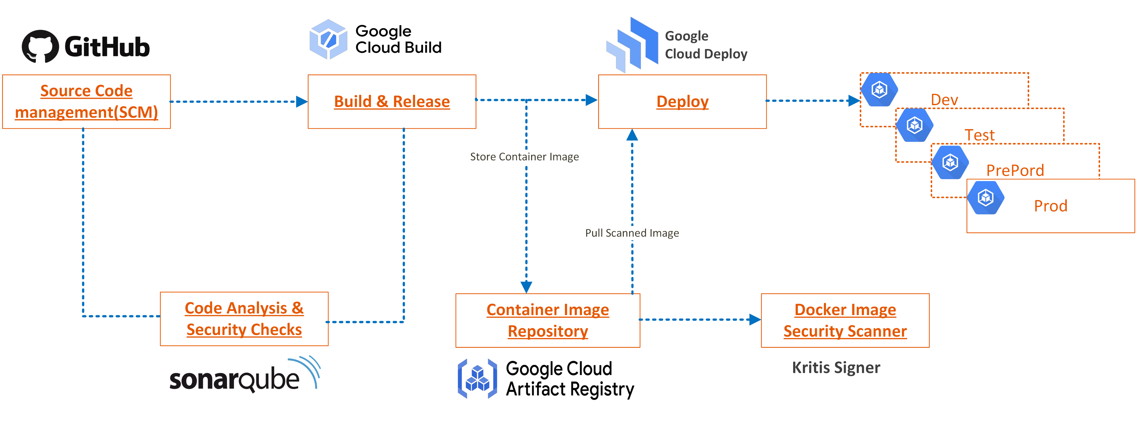

11.2 Required Gates
Gate | Minimum approval behavior
Peer review / branch protection | Required approvals enforced before merge to main.
SAST / SCA / secrets / container scan | Block on critical / high findings unless an approved, time-bound exception exists.
Image signing / provenance | Mandatory artifact evidence before production.
IaC policy | Block public / unauthenticated ingress and broad IAM.
Test evidence | Unit, integration, authorization-negative and security tests attached to the release.
Production approval | Named change approver and operations readiness satisfied.

11.3 Patch and Dependency Management
Dependencies and base images are inventoried. Security advisories are triaged against Vodafone remediation timelines. The React / Node build tooling, the Python / FastAPI dependencies and the container base images are upgraded through tested releases. Emergency fixes use the same controlled build / sign / deploy path; manual production modification is prohibited.

12. Future Roadmap
Phase 1 (Initial Release)
- Dashboard with core analytics and driver visualizations.
- Google Groups application access control, resolved through Identity-Aware Proxy.
- BigQuery Row-Level Security (by market) and Column-Level Security (Policy Tags) enforced at query time.
Phase 2 (Future Enhancements)
- AI-powered natural-language interaction – Phase 2 future enhancement.
- In-dashboard chatbot for conversational insight – Phase 2 future enhancement.
- Simulation view allowing users to adjust factors and evaluate relative odds against a baseline.
- Overview page providing a consolidated summary of key metrics and insights.
The Phase 1 architecture does not depend on any Phase 2 capability. AI capabilities are future enhancements and are not part of the Phase 1 production architecture.

13. Appendices

Appendix A – Glossary
Term | Meaning
BigQuery | Google Cloud managed data warehouse holding published analytics outputs and semantic views.
Cloud Run | Serverless container platform hosting the frontend and backend.
IAP | Google Cloud Identity-Aware Proxy.
Cloud Armor | Google Cloud WAF and edge protection.
SSO | Corporate single sign-on, resolved through Identity-Aware Proxy.
RLS | Row-Level Security in BigQuery, restricting rows by market.
CLS | Column-Level Security in BigQuery, restricting sensitive columns.
Policy Tags | BigQuery taxonomy tags used to apply Column-Level Security and pseudo-anonymization.
Pseudo-anonymization | Protection of applicable columns so that raw sensitive values are not exposed to the application.
SPDA | Vodafone security / privacy design assurance process.
C3 | Vodafone classification / handling level for the application; final designation by the Information Owner.
UAM | User Access Management.

Appendix B – Source Register
This HLD was grounded in the following sources. Where it proposes a control or governance detail not explicitly present in these sources, that item is marked TBC and remains subject to Vodafone policy and reviewer confirmation.
- HR Insights Platform baseline HLD – primary baseline for data, access, security and operations content.
- Latest HR Insights Platform solution architecture diagram – authoritative source for the target architecture, components and data flow.

